Instructions for Measuring Vision using the Printable HOTV Column

Video guide: https://vimeo.com/398735742

- Print a full-sized HOTV vision chart and matching card from the following links:
  - Printable HOTV Chart, HOTV Matching Card
  - Confirm that the distance between vertical lines is 2.5 inches (guide on sheet)
  - Fold chart so that letters are on outside, and secure with a paper clip or tape
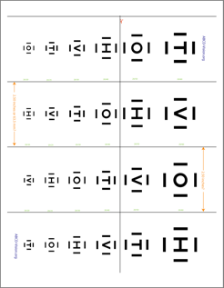

- Set up the testing area:
  - Give your child the matching guide (if needed) and practice the test
  - Place a chair at one end of the room
  - Measure 10 feet from the back of the chair to the spot that you will hold the HOTV chart when testing vision (*10 ft = 11 8.5x11” printer pages end to end)

- Check your child’s vision:
  - If you child wears glasses, measure vision with glasses on.
  - Cover your child’s left eye first to measure vision in the right eye. Repeat with the right eye covered to measure vision in the left eye. Make sure your child is not peeking.
  - Stand 10 feet away and randomly spin the chart and point to the first letter under the black line (20/40). If they can identify this letter, move to the next smallest letter. If they cannot read it, go up a line. Your child can name the letter or point to the letter on the matching card).
  - Your child’s vision is the smallest size of letters for which your child identify at least ¾ correctly. Note the fraction that corresponds to this size of letters (20/___).

- Record your child’s vision on the “Visual Acuity Recording Sheet” on the last page (20/__). Record how reliable you think the vision test was.

- Tips for measuring vision:
  - Check your child’s vision with glasses.
  - Be sure to pay attention to which eye you are checking and record the results immediately after testing.
  - No peeking! Make sure your child’s eye is patched or completely covered (e.g. with an eye patch, tissues with tape or palm of hand).
  - If needed, practice first to make sure your child understands the “game”. For the HOTV test, it is ok to stand close to your child to practice.
  - Do not give your child hints.

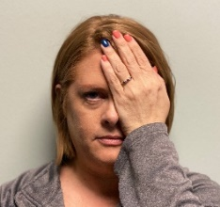
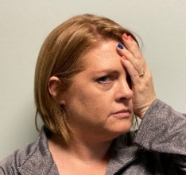
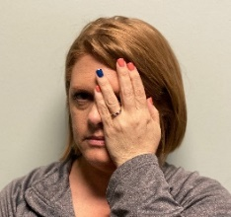
d
- Correct covering of eye!
- Palm of hand covering eye.
- No peeking through fingers!
- Not using palm of hand.
- Peeking through fingers.
- Turning head.
- Peeking through edge of hand.

Home Visual Acuity Testing
An important part of an eye examination is measuring vision—how well your child can see on an eye chart.

If possible, please check and record your child’s vision in their right eye and their left eye. If they have glasses, please make sure they are wearing them during the test.

Method used:

HOTV Letters

Glasses on?

Yes No

Vision: Reliability:
Right eye: 20 / 1 2 3 4 5

Low Medium High

Left eye: 20 / 1 2 3 4 5

