Instructions for Android Snellen Chart App

Video guides:
https://www.youtube.com/watch?v=Clp_axzAfeQ&fbclid=IwAR3_7_bUlmzJXASD6tNMo8-0hHKUkuaSjOqMw9kV_zYlj-uduN4NOZ3pDEg

https://www.youtube.com/watch?v=edAkxJmgymg&fbclid=IwAR1z_XEt077uKwkojYXGbCGWQqsxf5k-KzxRx-kI7RDTCacK-QhGUt9mFN0

- Download the Snellen Chart App from Google Play for Android Store.

- Open the App and go the to “Settings” in the right upper corner of the screen.
- Change “Distance from User to Display” to 305 centimeters. This is equivalent to 10 feet.
- If your child does not know letters, you can change the setting in the “Selected Optotype” section. Snellen Letters is the default but you can instead select the LEA Symbols (shapes) or HOTV.

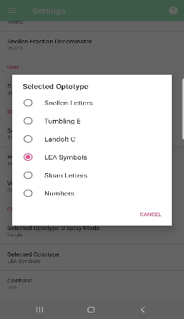
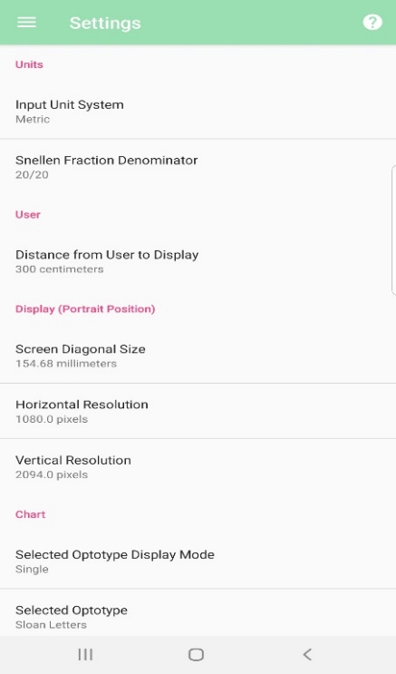
Selected Optotype
Snellen Letters
Tumbling E
Landolt C
LEA Symbols
Sloan Letters
Numbers

- Set up the testing area:
  - If needed, give your child a paper with large HOTV letters to match
  - Place a chair at one end of the room
  - Measure 10 feet from the back of the chair to the spot that you will hold the phone when testing vision (*10 ft = 11 8.5x11” printer pages end to end)

- Check your child’s vision:
  - If you child wears glasses, measure vision with glasses on.
  - Cover your child’s left eye first to measure vision in the right eye. Repeat with the right eye covered to measure vision in the left eye. Make sure your child is not peeking.
  - Continue swiping down to make the letters or shapes smaller until your child can no longer see what is on the screen.
  - Your child’s vision is the smallest line of letters for which your child identify at least half of the letters correctly. Note the fraction that corresponds to this size of letters (20/___).

- Record your child’s vision on the “Visual Acuity Recording Sheet” on the last page (20/__). Record how reliable you think the vision test was.

- Tips for measuring vision:
  - Check your child’s vision with glasses.
  - Be sure to pay attention to which eye you are checking and record the results immediately after testing.
  - No peeking! Make sure your child’s eye is patched or completely covered (e.g. with an eye patch, tissues with tape or palm of hand).
  - If needed, practice first to make sure your child understands the “game”. For the HOTV test, it is ok to stand close to your child to practice.
  - Do not give your child hints.

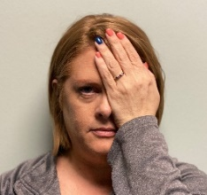
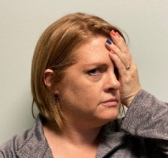
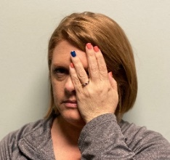
d
- Correct covering of eye!
- Palm of hand covering eye.
- No peeking through fingers!
- Not using palm of hand.
- Peeking through fingers.
- Turning head.
- Peeking through edge of hand.

Home Visual Acuity Testing
An important part of an eye examination is measuring vision—how well your child can see on an eye chart.

If possible, please check and record your child’s vision in their right eye and their left eye. If they have glasses, please make sure they are wearing them during the test.

Method used:

HOTV Letters

Glasses on?

Yes No

Vision: Reliability:
Right eye: 20 / 1 2 3 4 5

Low Medium High

Left eye: 20 / 1 2 3 4 5

